Chemically cell membrane consists of __________and small quantity of Carbohydrates
A. Proteins 10-20%
B. Proteins 60-80%, Lipids 20-40%
C. Lipids 30-60%
D. Proteins 80-10% and Lipids 10-60%
ANSWER: B
Cell membranes contain a variety of biological molecules, notably
A. Carbohydrates and lipids
B. Lipids and proteins
C. Proteins and Carbohydrates
D. Cholesterol and proteins
ANSWER: B
In the plant cell, this layer is present nearest to the plasma membrane
A. Tonoplast
B. Middle Lamella
C. Secondary Wall
D. Primary Wall
ANSWER: C
Plasma membranes contain__________, predominantly glycoproteins, but with some glycolipids
A. Proteins
B. Lipids
C. Carbohydrates
D. Cholesterol
ANSWER: C
The diagram shows the fluid mosaic model of membrane structure. What are X, Y and Z?
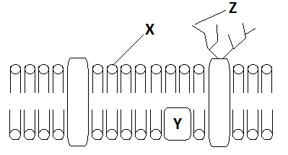
 | X | Y | Z
A. | Lipid | Carbohydrate | Protein
B. | Lipid | Peripheral Protein | Carbohydrate
C. | Protein | Carbohydrate | Lipid
D. | Lipid | Integral Protein | Carbohydrate
ANSWER: B
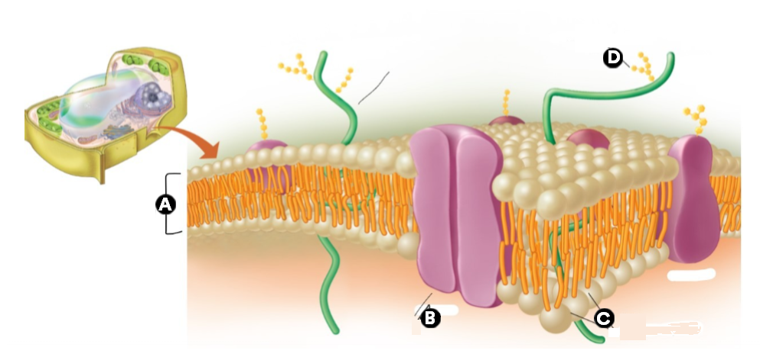
The diagram shows the model of membrane structure, what does A represent in the diagram?
A. Phospholipids
B. Carbohydrate chain
C. Protein
D. Phospholipids bilayer
ANSWER: D

The diagram shows the model of membrane structure, what does B represent in the diagram?
A. Phospholipids
B. Carbohydrate chain
C. Protein
D. Phospholipids bilayer
ANSWER: C

The diagram shows the model of membrane structure, what does C represent in the diagram?
A. Phospholipids
B. Carbohydrate chain
C. Protein
D. Phospholipids bilayer
ANSWER: A

The diagram shows the model of membrane structure, what does D represent?
A. Phospholipids
B. Carbohydrate chain
C. Protein
D. Phospholipids bilayer
ANSWER: B
The plasma membrane is also called:
A. Cell membrane
B. Plasmolemma
C. Cell surface membrane
D. All of these
ANSWER: D
The fluidity of the plasma membrane increases with which of the following?
A. Increase in saturated fatty acids in the membrane
B. Increase in glycolipid content in the membrane
C. Increase in phospholipid content in the membrane
D. Increase in unsaturated fatty acids in the membrane
ANSWER: D
Singer and Nicolson proposed a working model of the plasma membrane which is called:
A. Watson and cricks Model
B. Fluid Mosaic Model
C. Induce Fit Model
D. Dalton’s Atomic Model
ANSWER: B
The cell membrane is _______________to ions, small molecules and larger molecules
A. Permeable
B. Semi-Permeable (Selectively Permeable)
C. Impermeable
D. None of these
ANSWER: B
According to the fluid mosaic model:
A. There is a lipid layer in which protein molecules are present
B. There is a protein bilayer in which phospholipids are embedded
C. There is a lipid bilayer in which protein molecules are embedded
D. There is a carbohydrate chain linked with proteins
ANSWER: C
The membrane is about:
A. 2 nm thick
B. 4 nm thick
C. 15 nm thick
D. 7 nm thick
ANSWER: D
Carbohydrates attached to proteins:
A. Glycoproteins
B. Glycolipids
C. Nucleoprotein
D. Lipoprotein
ANSWER: A
Carbohydrates attached to lipids:
A. Glycoproteins
B. Glycolipids
C. Nucleoprotein
D. Lipoprotein
ANSWER: B
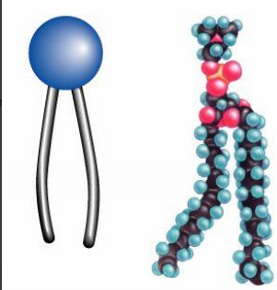
This image is an example of a phospholipid. Which part of a phospholipid is HYDROPHOBIC?
A. Head
B. Tail
C. Both A and B
D. None of these
ANSWER: B

This image is an example of a phospholipid. Which part is HYDROPHILIC?
A. Head
B. Tail
C. Both A and B
D. None of these
ANSWER: A
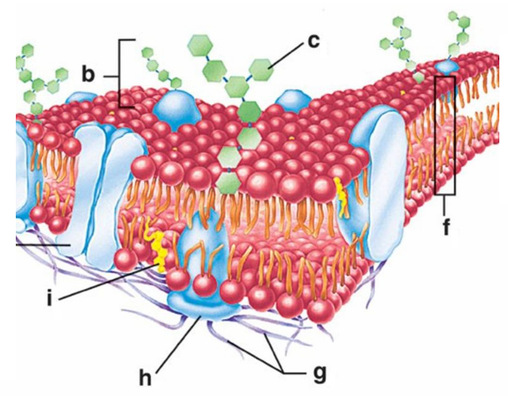
In the above diagram, identify cholesterol molecule.
A. Structure c
B. Structure f
C. Structure g
D. Structure i
ANSWER: D
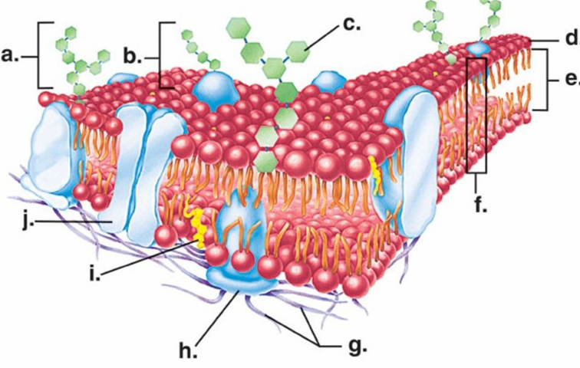
In the above diagram, identify a peripheral protein:
A. Structure a
B. Structure b
C. Structure g
D. Structure h
ANSWER: D
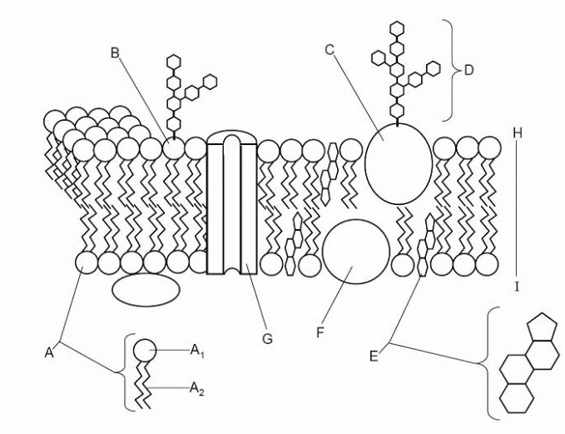
Which structure is the hydrophilic polar head of the phospholipid molecule?
A. F
B. D
C. C
D. A1
ANSWER: D
In ________ the Fluid—Mosaic Membrane Model of membrane structure was proposed
A. 1972
B. 1589
C. 1878
D. 1987
ANSWER: A
The plasma membrane is:
A. Symmetrical
B. Outermost layer of plant cell
C. Asymmetrical
D. Solid in nature
ANSWER: C
The fluidity of the plasma membrane is dependent on lipids components including:
A. Phospholipids
B. Glycolipids
C. Cholesterol
D. All of these
ANSWER: D

The fluidity of the plasma membrane increases with which of the following?
A. Increase in saturated fatty acids in the membrane
B. Increase in glycolipid content in the membrane
C. Increase in phospholipid content in the membrane
D. Increase in unsaturated fatty acids in the membrane
ANSWER: D
These form channels to allow the movement of molecules.
A. Phospholipid
B. Carbohydrates
C. Cholesterol
D. Proteins
ANSWER: D
It helps the plasma membrane to retain its fluidity
A. Glycolipids
B. Carbohydrates
C. Cholesterol
D. Proteins
ANSWER: C
Which of the following is involved in the passage of molecules through the membrane?
A. Receptor molecules
B. Enzymes
C. Channel and carrier proteins
D. Antigens
ANSWER: C
Which protein receives signals from other cells?
A. Receptor molecules
B. Enzymes
C. Channel and carrier proteins
D. Antigens
ANSWER: A
Which protein enable cells to recognize other cells?
A. Receptor molecules
B. Enzymes
C. Channel and carrier proteins
D. Antigens
ANSWER: D
__________ is the only enzyme that produces cAMP
A. NAD
B. Lipase
C. Adenylyl cyclase
D. Phosphatase
ANSWER: C

Which of the following acts as cell surface maker?
A. Phospholipid
B. Protein
C. Glycolipids and glycoproteins
D. Cholesterol
ANSWER: C
Glycolipid’s main function is
A. Retain fluidity
B. Cell Recognition
C. Movement of molecules
D. None of these
ANSWER: B
Glycolipid refers to
A. Proteins with a carbohydrate
B. Lipids with a carbohydrate
C. Nucleic acid with a protein
D. Protein with a lipid
ANSWER: B
Glycoprotein refers to
A. Proteins with a carbohydrate
B. Lipids with a carbohydrate
C. Nucleic acid with a protein
D. Protein with a lipid
ANSWER: A
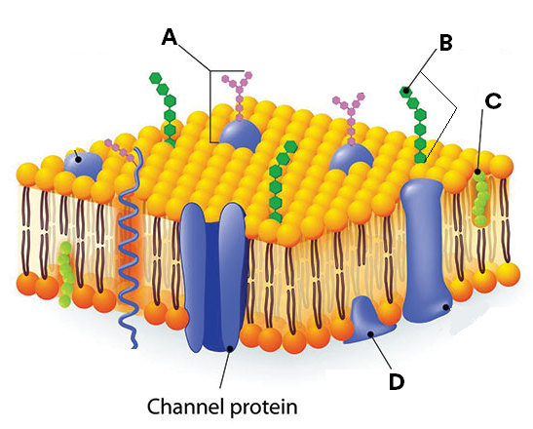
In the above diagram, what does A represent?
A. Glycolipid
B. Glycoprotein
C. Nucleoprotein
D. Lipoprotein
ANSWER: B

In the above diagram, what does B represent?
A. Glycolipid
B. Glycoprotein
C. Nucleoprotein
D. Lipoprotein
ANSWER: A
Glycoproteins are protein molecules attached to the short chains of:
A. Carbohydrates
B. Lipids
C. DNA
D. RNA
ANSWER: A

Transport across plasma membrane occurs to:
A. Obtain nutrients
B. Excrete waste substances
C. Generate ionic gradient essential for nervous and muscular activity
D. All of these
ANSWER: D
The process by which the cell membrane absorbs solid particles is called:
A. Pinocytosis
B. Diffusion
C. Phagocytosis
D. Absorption
ANSWER: C
____________ is a process in which the cell membrane helps to take in material by infolding in the form of vacuole
A. Endocytosis
B. Exocytosis
C. Both A and B
D. None of these
ANSWER: A
Which type of movement goes from low to high concentration?
A. Active Transport
B. Diffusion
C. Osmosis,
D. Facilitated Diffusion
ANSWER: A
Which type of movement requires energy?
A. Active Transport
B. Diffusion
C. Osmosis,
D. Facilitated Diffusion
ANSWER: A
The ___________ regulates the transport of materials entering and exiting the cell
A. Plasma membrane
B. Nucleus
C. Cytoplasm
D. Tonoplast
ANSWER: A
The process by which the cell membrane absorbs liquid is called:
A. Pinocytosis
B. Diffusion
C. Phagocytosis
D. Absorption
ANSWER: A
Cell eating is called:
A. Phagocytosis
B. Pinocytosis
C. Both A and B
D. None of these
ANSWER: A
Cell drinking is called:
A. Phagocytosis
B. Pinocytosis
C. Both A and B
D. None of these
ANSWER: B
Which of the following maintains a suitable pH and ionic concentration within the cell for enzyme activity?
A. Cytoplasm
B. Cell membrane
C. Nucleus
D. ER
ANSWER: B

